■ マス目に１文字ずつ入れて，右ページの動物や昆虫の名前を書こう。

 |  |  |  |  |  |  |  | ① |  |  | ②
 |  |  |  |  |  |  |  | M |  |  | P
 |  |  |  |  | ① |  |  |  | N | ②
 |  |  |  |  |  | ③ |  |  |  |  |  |  | ④ |  |  | ⑤
 |  |  |  |  | ③ | E |  |  |  |  |  |  |  |  |  | S
 |  |  |  |  |  |  |  | Y
 |  |  | ⑥ |  |  |  |  |  |  | ④ |  |  | G |  | ⑤
 |  |  |  |  | ⑦ |  |  |  |  |  | ⑨ |  |  | ⑧ | F |  |  | G
 | ⑥ |  |  |  | S |  |  |  |  | ⑦ |  |  |  | D
 |  |  |  |  |  |  |  |  | ⑧ |  |  |  | ⑨ |  |  | W
⑩ | B |  |  |  |  | E |  |  |  |  | R
 |  |  | ⑪
 |  |  |  |  | W

monkey lion horse tiger sparrow

Tool Box
dog duck pig beetle fox cow
panda eagle ant elephant swallow
frog bird cat bear

タテ | 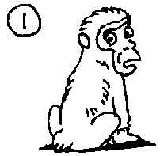 |  | 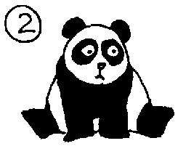 |  | 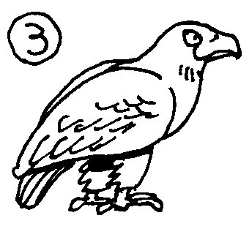 |  | 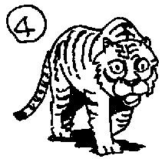
 | 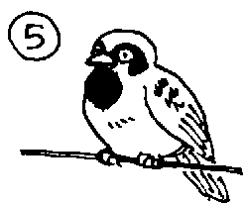 |  | 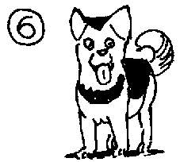 |  | 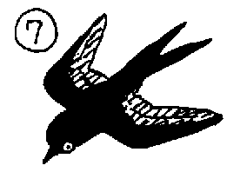 |  | 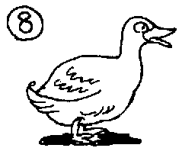




ヨコ | 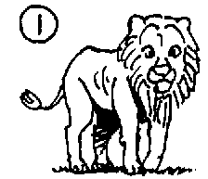 |  | 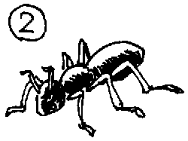 |  | 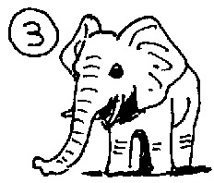 |  | 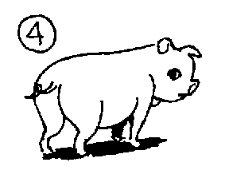
 | 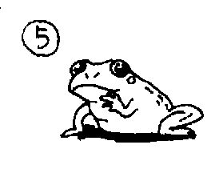 |  | 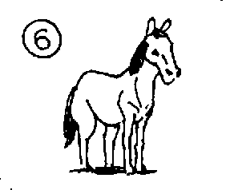 |  | 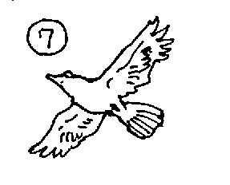 |  | 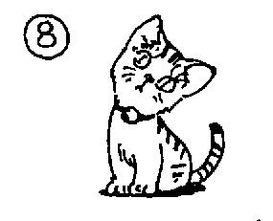
 | 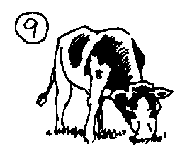 |  | 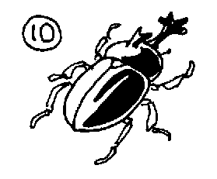 |  | 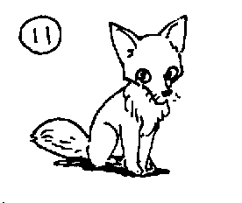

■ マス目に１文字ずつ入れて，右ページの動物や昆虫の名前を書こう。

 |  |  |  |  |  |  |  | ① |  |  | ②
 |  |  |  |  |  |  |  | M |  |  | P
 |  |  |  |  | ① | L | I | O | N | ② | A | N | T
 |  |  |  |  |  |  |  | N |  |  | N
 |  |  |  |  |  | ③ |  | K |  |  | D |  | ④ |  |  | ⑤
 |  |  |  |  | ③ | E | L | E | P | H | A | N | T |  |  | S
 |  |  |  |  |  | A |  | Y |  |  |  |  | I |  |  | P
 |  |  | ⑥ |  |  | G |  |  |  | ④ | P | I | G |  | ⑤ | A
 |  |  | D |  | ⑦ | L |  |  |  |  | ⑨ |  | E | ⑧ | F | R | A | G
 | ⑥ | H | O | R | S | E |  |  |  | ⑦ | B | I | R | D |  | R
 |  |  | G |  | W |  |  |  |  |  | E |  |  | U |  | O
 |  |  |  |  | A |  |  |  | ⑧ | C | A | T | ⑨ | C | O | W
⑩ | B | E | E | T | L | E |  |  |  |  | R |  |  | K
 |  |  |  |  | L
 |  |  | ⑪ | F | O | X
 |  |  |  |  | W

monkey lion horse tiger sparrow

Tool Box
dog duck pig beetle fox cow
panda eagle ant elephant swallow
frog bird cat bear

タテ

ヨコ

