英語コミュニケーションⅠ Special Lesson presented by CNN
Class: ________ Number: ________ Name: ____________________
Today’s goal

Overload of immigrants
Dicto-gloss
①3回聞く中で、読み取れたことをできるだけ多く書きとめる。
②キーワードは書いても良いが，文で書かないこと。⇒完成したら友達と共有しよう!
Scene前半Dicto-gloss

Story Mapping

Scene後半Dicto-gloss

Story Mapping

Summary(4～8sentences)
自分なりにまとめてみよう! 完成したら，友達のsummaryも見てみよう!
Comments(友達からもらう)＊相手の意見に対して必ず質問や確認をする。

Group debate
“Should we accept immigrants for better future of Japan?”
Brainstom ideas for this topic. Write down keywords only.
No
Yes

＊下線部は好きな表現に変えて良い。
パターン①
A：I think __________________＿＿＿, because _______________________________＿＿.
～2分～
相手からの反論
B：You said _______________________________________________＿＿＿＿＿＿＿＿＿＿.
However, I don’t think so.
This is because ____________________________________________＿＿＿＿＿＿＿＿.
～1分～
結論
A：I strongly believe _______________________________＿＿＿＿_____________________.

➡役割を変えて
パターン②
B：I think __________________＿＿＿, because _______________________________＿＿.
～2分～
相手からの反論
A：You said _______________________________________________＿＿＿＿＿＿＿＿＿＿.
However, I don’t think so.
This is because ____________________________________________＿＿＿＿＿＿＿＿.
～1分～
結論
B：I strongly believe _______________________________＿＿＿＿_____________________.

Reflection
I could tell what I wanted to say. |  | I think so. | To some extent. | I don’t think so.
I could understand what the other party said. |  | I think so. | To some extent. | I don’t think so.
・It is wrong to say that～, because _______________________.
・You said that. This is not true, because ___________________.
・I don’t understand why you think～,because ________________.

●自分の本当の考えについてwriting!!
“Should we accept immigrants for better future of Japan?” 【 Yes / No 】
＿＿＿＿＿ ＿＿＿＿＿ ＿＿＿＿＿ ＿＿＿＿＿ ＿＿＿＿＿ ＿＿＿＿＿ ＿＿＿＿＿
＿＿＿＿＿ ＿＿＿＿＿ ＿＿＿＿＿ ＿＿＿＿＿ ＿＿＿＿＿ ＿＿＿＿＿ ＿＿＿＿＿
＿＿＿＿＿ ＿＿＿＿＿ ＿＿＿＿＿ ＿＿＿＿＿ ＿＿＿＿＿ ＿＿＿＿＿ ＿＿＿＿＿
＿＿＿＿＿ ＿＿＿＿＿ ＿＿＿＿＿ ＿＿＿＿＿ ＿＿＿＿＿ ＿＿＿＿＿ ＿＿＿＿＿
＿＿＿＿＿ ＿＿＿＿＿ ＿＿＿＿＿ ＿＿＿＿＿ ＿＿＿＿＿ ＿＿＿＿＿ ＿＿＿＿＿
＿＿＿＿＿ ＿＿＿＿＿ ＿＿＿＿＿ ＿＿＿＿＿ ＿＿＿＿＿ ＿＿＿＿＿ ＿＿＿＿＿
＿＿＿＿＿ ＿＿＿＿＿ ＿＿＿＿＿ ＿＿＿＿＿ ＿＿＿＿＿ ＿＿＿＿＿ ＿＿＿＿＿
＿＿＿＿＿ ＿＿＿＿＿ ＿＿＿＿＿ ＿＿＿＿＿ ＿＿＿＿＿ ＿＿＿＿＿ ＿＿＿＿＿
＿＿＿＿＿ ＿＿＿＿＿ ＿＿＿＿＿ ＿＿＿＿＿ ＿＿＿＿＿ ＿＿＿＿＿ ＿＿＿＿＿
＿＿＿＿＿ ＿＿＿＿＿ ＿＿＿＿＿ ＿＿＿＿＿ ＿＿＿＿＿ ＿＿＿＿＿ ＿＿＿＿＿
＿＿＿＿＿ ＿＿＿＿＿ ＿＿＿＿＿ ＿＿＿＿＿ ＿＿＿＿＿ ＿＿＿＿＿ ＿＿＿＿＿
＿＿＿＿＿ ＿＿＿＿＿ ＿＿＿＿＿ ＿＿＿＿＿ ＿＿＿＿＿ ＿＿＿＿＿ ＿＿＿＿＿
＿＿＿＿＿ ＿＿＿＿＿ ＿＿＿＿＿ ＿＿＿＿＿ ＿＿＿＿＿ ＿＿＿＿＿ ＿＿＿＿＿
＿＿＿＿＿ ＿＿＿＿＿ ＿＿＿＿＿ ＿＿＿＿＿ ＿＿＿＿＿ ＿＿＿＿＿ ＿＿＿＿＿
＿＿＿＿＿ ＿＿＿＿＿ ＿＿＿＿＿ ＿＿＿＿＿ ＿＿＿＿＿ ＿＿＿＿＿ ＿＿＿＿＿
＿＿＿＿＿ ＿＿＿＿＿ ＿＿＿＿＿ ＿＿＿＿＿ ＿＿＿＿＿ ＿＿＿＿＿ ＿＿＿＿＿
＿＿＿＿＿ ＿＿＿＿＿ ＿＿＿＿＿ ＿＿＿＿＿ ＿＿＿＿＿ ＿＿＿＿＿ ＿＿＿＿＿
＿＿＿＿＿ ＿＿＿＿＿ ＿＿＿＿＿ ＿＿＿＿＿ ＿＿＿＿＿ ＿＿＿＿＿ ＿＿＿＿＿
＿＿＿＿＿ ＿＿＿＿＿ ＿＿＿＿＿ ＿＿＿＿＿ ＿＿＿＿＿ ＿＿＿＿＿ ＿＿＿＿＿
＿＿＿＿＿ ＿＿＿＿＿ ＿＿＿＿＿ ＿＿＿＿＿ ＿＿＿＿＿ ＿＿＿＿＿ ＿＿＿＿＿
＿＿＿＿＿ ＿＿＿＿＿ ＿＿＿＿＿ ＿＿＿＿＿ ＿＿＿＿＿ ＿＿＿＿＿ ＿＿＿＿＿
＿＿＿＿＿ ＿＿＿＿＿ ＿＿＿＿＿ ＿＿＿＿＿ ＿＿＿＿＿ ＿＿＿＿＿ ＿＿＿＿＿
＿＿＿＿＿ ＿＿＿＿＿ ＿＿＿＿＿ ＿＿＿＿＿ ＿＿＿＿＿ ＿＿＿＿＿ ＿＿＿＿＿( )語
＊If you finish writing this, please evaluate your writing
according to the evaluation sheet below.
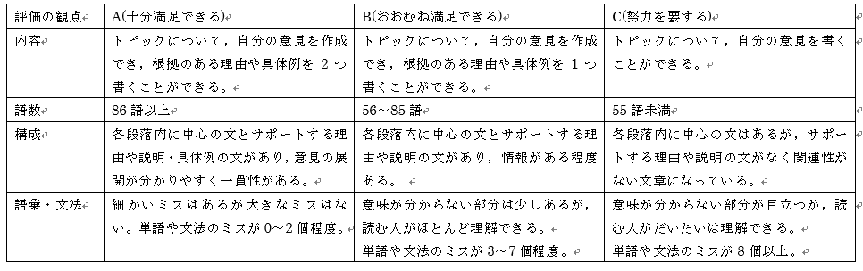

Check new words! (宿題用)
＊If you can, paraphrase these following words.
英単語 | 英語で言い換え | 意味(日本語)

